1. Topic Name: **Throttle Car Sales and Service**
2. *Working Flowchart:*

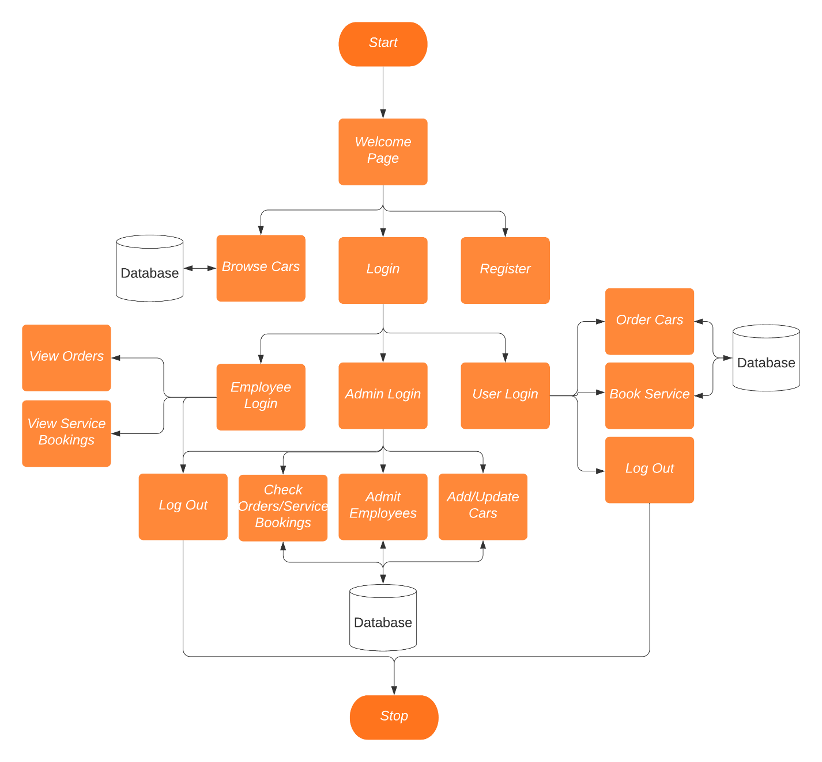

1. Step-by-Step Explanation of Flowchart:
2. Users will see a welcome page with options to change page to Browse Cars, Login or Register
3. Employees, Admins and Users have separate Login Credentials
4. **Employees** will be able to view orders and service bookings
5. **Admins** can admit employees, check orders and service bookings, and add and update cars
6. **Normal Users** can order cars and book service
7. All the 3 types of users can logout
8. Additional Features: Payment Gateway, Contact Us, Add Branch Locations